Outbound Documentation Tool

Student process notes 1
Study Abroad placement 2
Study Abroad placement – (Turing) 8
Work Abroad placement – (non-Turing) 16
Work Abroad placement – (Turing) 22
Work placement - UK 31

Student process notes

This is a Tool in which you can update details for Study Abroad, check the status of required tasks, complete online tasks including completing a Pre-Departure Agreement, and upload relevant documents.
You can also see here what items you have that you still need to complete for your placement, and in what part of the semester or year you should be completing them.
1. Log in to MySaint
2. Locate the “My Study Abroad Administration” task under the title “Global Office – Outbound Placement Actions” within “My Courses” and click on it.
Now you’ll see a screen like this, showing you a checklist of all the items you need to complete for your placement. These are split into sections for things to do before you go, things to complete for when you arrive, before you leave, and on your return:
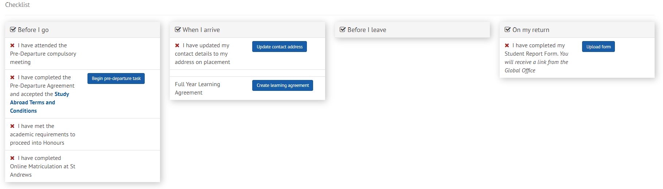
You will see that each element has either a red cross or a green tick next to it. This shows whether or not the element has been completed.
Some of the elements are completed by updating the task directly in the Outbound Documentation Tool; some of them are updated because you complete a task like attending a Pre-Departure briefing and because we then update your record for you; and some are completed because you upload a document to the Tool yourself.
The tasks are dependent on your type of placement.

Study Abroad placement

As mentioned above, the tasks you will see are dependent on your type of placement. For this type of placement, you will see a screen like this showing all of the tasks you should complete.
They are split into sections. Under the column “Before I go” you have the following four tasks:
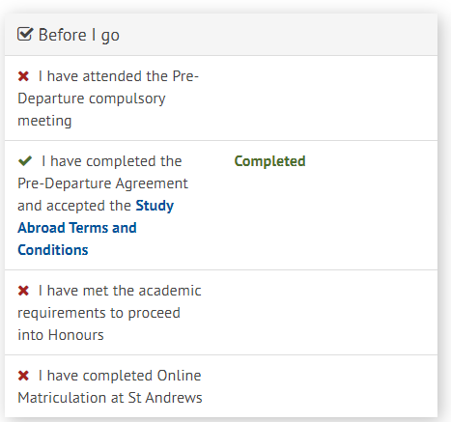
1. Attend the Pre-Departure compulsory meeting.
This is an event run by the Global Office and you will be informed about it. We will take a record of your attendance and update the Tool for in the days after the meeting.
2. Complete the Pre-Departure Agreement and accept Study Abroad Terms and Conditions.
This is a two-stage task. Firstly, you should click on the blue link to the Study Abroad Terms and Conditions. This will take you to our website. Select the link for Programme terms and conditions, and then the ones related to your type of placement, then read them and make sure you understand them.
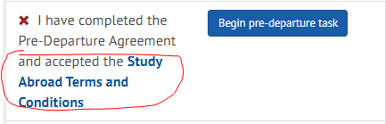
You will be asked to confirm you accept them as part of the Pre-Departure Agreement. Acceptance is a mandatory part of your eligibility for Study Abroad.
Next, click the button marked “Begin pre-departure task”.
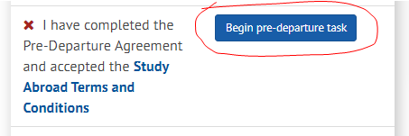
The task asks you five questions. You must answer them all. To do so, simply select the drop-down box on each question and answer it. These responses will feed through to our administrative view of your Agreement. Completing the task will update that element and mark it with a green tick.
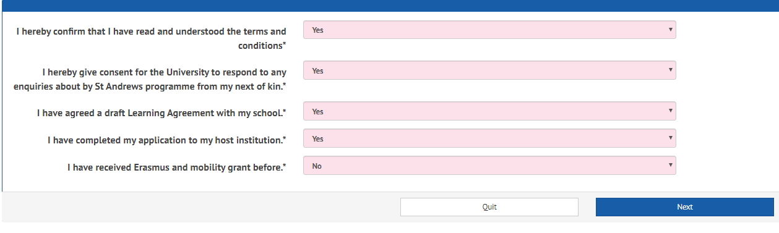
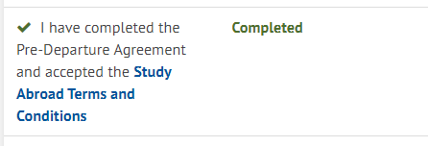
The next two elements in your “Before I go” section are validated when you complete a requirement outside of the tool.
3. The first is complete when you meet academic requirements to proceed to Honours which is a condition of your placement. This will be updated for you before your placement begins.
4. The second is complete when you finish Online Matriculation through the normal process each academic year. Both will be updated for you when they have been done.
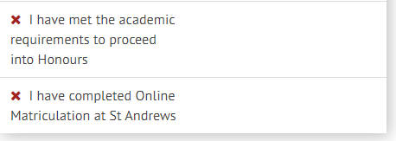
The next section is “When I arrive”. There are two elements to complete here.
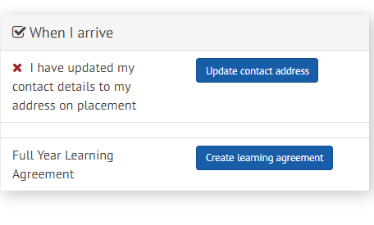
1. The first element is to ensure we have your correct contact details. This is extremely important so that we can contact you in case of need, so you must make sure they are always up-to-date. Once you reach your accommodation for your placement, you should click on the “Update contact address” link, update the information in the table below, and this will feed through to our other systems for you.
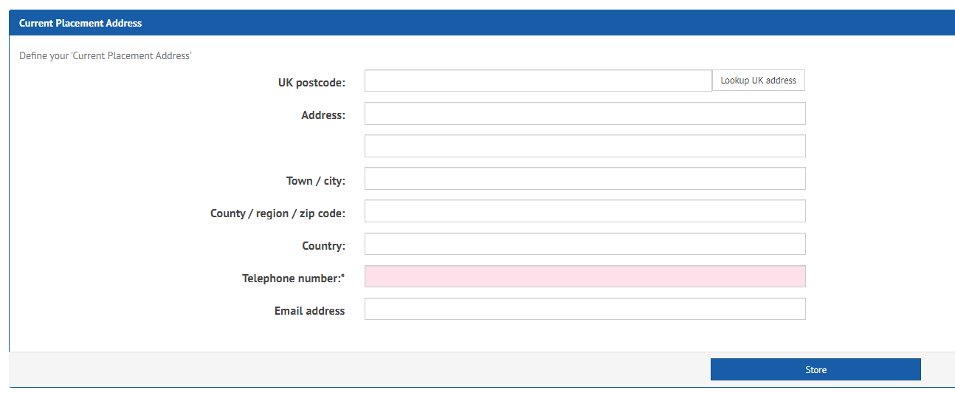
Although this will be marked complete once you have done this, you should remember to update your details through the normal task in MySaint any other time you move location within the same Study Abroad period.
2. The second element is an online task to allow you to complete a Learning Agreement with your Study Abroad Co-ordinator. You use this task to request the subject/s and module/s for your placement.
The period you see should match the one you are studying abroad for – if it doesn’t, don’t worry as you can tell us about any changes in the system. Full guidance notes for completing the learning agreement element are below.
The next section is “Before I leave”. This section is not relevant if you are a study abroad student on an activity that is not funded by the Turing scheme. Nothing will show here, and you should not have anything to complete in this section.
The final section is “On my return”. There is one item to complete here.
1. This task requires you to upload a document called a “Student Report Form”. This is a form that is used by the Global Office to help monitor placements abroad. We value your responses highly and rely on them to tell us about any issues, or any positives related to your placement. You will be sent a form by the Global Office at the end of your placement.
Once you have completed the form, save it to your computer and click “Upload form”.
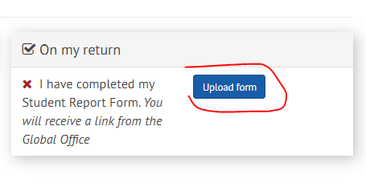
This will take you to a simple upload function. You can click “Browse my computer” to locate the file to upload.
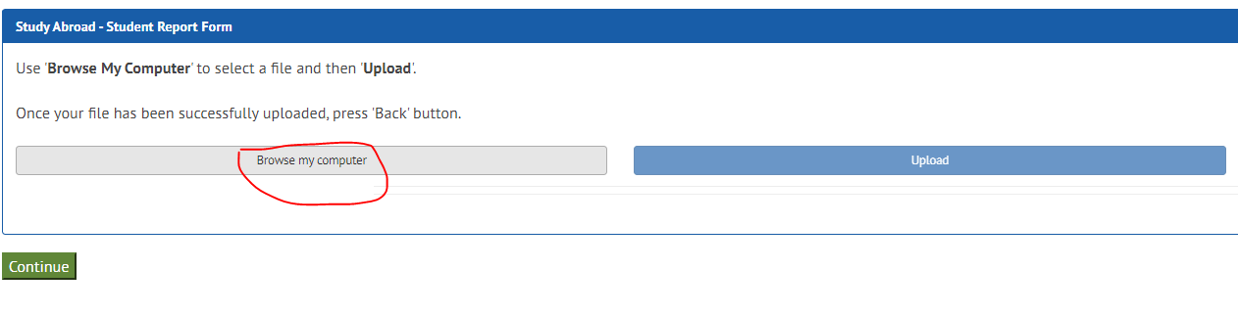
Next, select the file you want to upload. The system will show you the file name and size and open a box in which you should enter a name for the file, before clicking “Upload”.
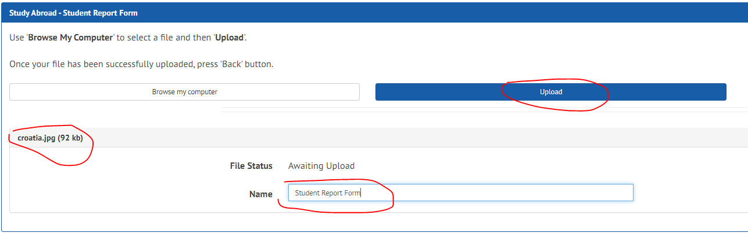
The Tool will tell you when the upload has been successful, and the file should be available for you to view by clicking on the file title.
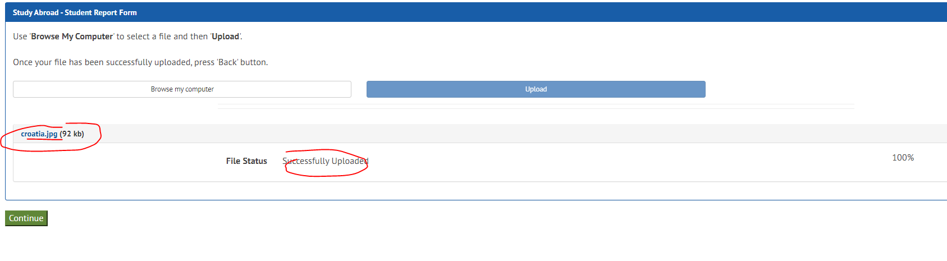
Once you are happy with the upload, click “Continue”.
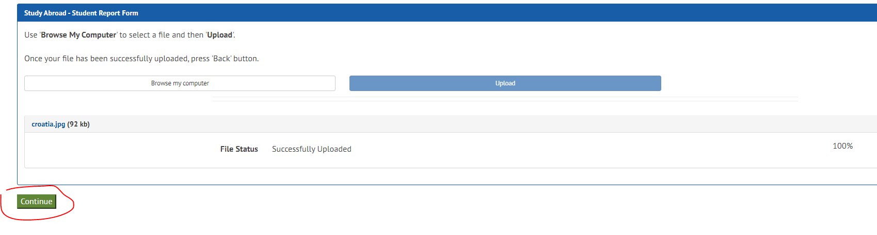
Now you will be taken to another screen where you can view, or remove the file, by either clicking the pen symbol or the dustbin symbol. If you are happy, click “Exit” to go back to the main page in the Tool. If required, you can delete and then upload another file.
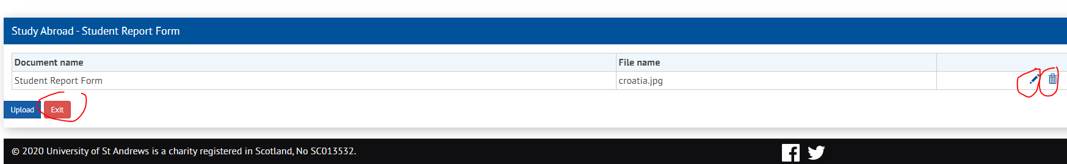
Once uploaded, and after you have clicked “Exit” you will be returned to the main screen and will see that the task is ticked green and is now complete.
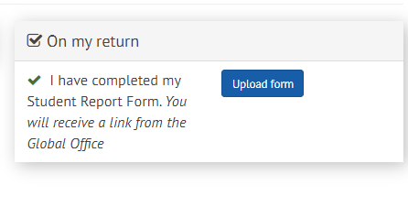

Study Abroad placement – (Turing)

As mentioned above, the tasks you will see are dependent on your type of placement. For this type of placement, you will see a screen like this showing all of the tasks you should complete. Note that some tasks will be marked with a green tick when completed, whereas others will have a red cross if they remain to be done.
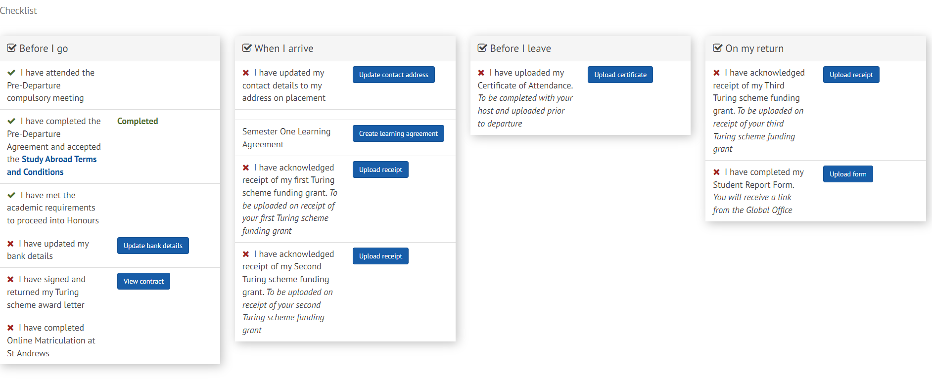

They are split into sections. Under the column “Before I go” you have the following six tasks:
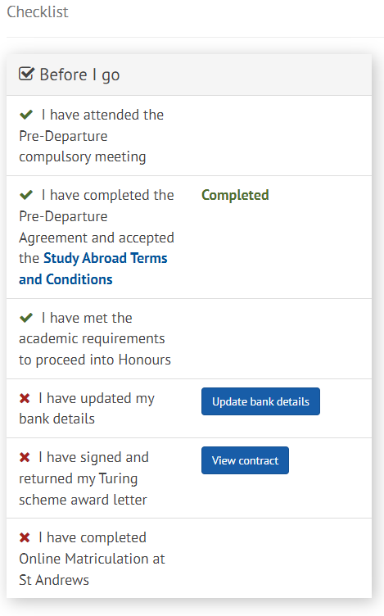
1. Attend the Pre-Departure compulsory meeting.
This is an event run by the Global Office and you will be informed about it. We will take a record of your attendance and update the Tool for in the days after the meeting.
2. Complete the Pre-Departure Agreement and accept Study Abroad Terms and Conditions.
This is a two-stage task. Firstly, you should click on the blue link to the Study Abroad Terms and Conditions. This will take you to our website. Select the link for Programme terms and conditions, and then the ones related to your type of placement, then read them and make sure you understand them.
You will be asked to confirm you accept them as part of the Pre-Departure Agreement. Acceptance is a mandatory part of your eligibility for Study Abroad.
Next, click the button marked “Begin pre-departure task”.
The task asks you five questions. You must answer them all. To do so, simply select the drop-down box on each question and answer it. These responses will feed through to our administrative view of your Agreement. Completing the task will update that element and mark it with a green tick.
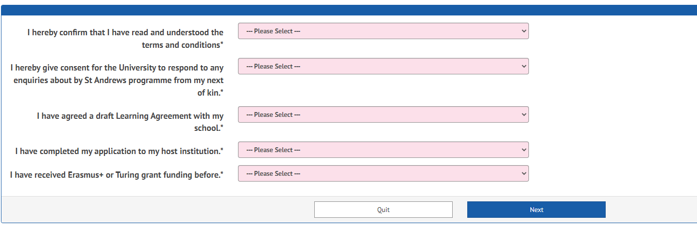
The next element in your “Before I go” section is validated when you complete a requirement outside of the tool.
3. This is complete when you meet academic requirements to proceed to Honours which is a condition of your placement. This will be updated for you before your placement begins.
4. Next, you have the ability to access a tool to update your bank details. You should always check that you have the relevant bank details listed in MySaint.
This task feeds through to your details and allows you to add the account information so that we can make payments to you for your Turing scheme grant.
Once you have completed it, the task will show with a green tick next to that element.
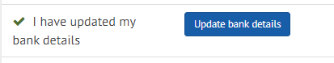
5. Next you need to ensure that you have checked, signed, and returned your Turing award letter. This will be sent to you via email after your placement has been confirmed, in the summer. You should check it carefully, complete any missing elements, sign it, and return it to the Global Office at outbound@st-andrews.ac.uk
We will upload it for you, and you will be able to see it by clicking “View contract”.
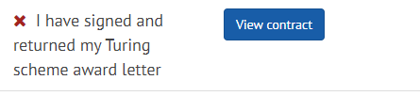
6. The sixth task is complete when you finish Online Matriculation through the normal process each academic year. Both will be updated for you when they have been done.
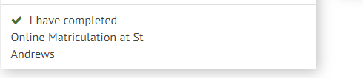

The next section is “When I arrive”. There are four elements to complete here.
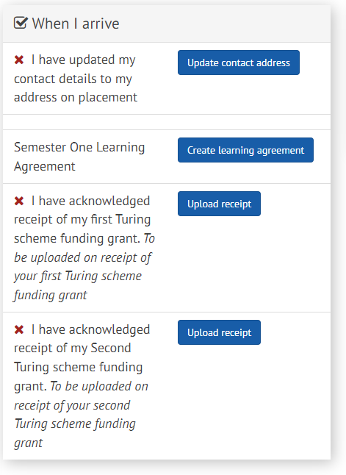
1. The first element is to ensure we have your correct contact details.
This is extremely important so that we can contact you in case of need, so you must make sure they are always up to date. Once you reach your accommodation for your placement, you should click on the “Update contact address” link, update the information in the table below, and this will feed through to our other systems for you.
Although this will be marked complete once you have done this, you should remember to update your details through the normal task in MySaint any other time you move location within the same Study Abroad period.
2. Task two is to create an online Learning Agreement.
This should be done before or at the start of your placement, and should be completed by you and your Study Abroad Co-ordinator through the system. Separate instructions are available.
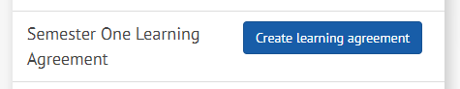
3, 4. Items 3 and 4 are both for upload of receipts for your Turing scheme grant payments.
Grants are paid in instalments. You will have received a message from us with your Turing scheme award letter which will explain how many payments you will receive. This depends on your placement duration. If you only receive two payments, you DO NOT need to use the Second grant receipt task. You will also see how much you will be paid at the outset of your placement in the same message. You will receive that amount before or near the start of your placement as long as you have completed the required tasks beforehand, including returning a fully signed contract to us. Second and third instalments are released during the placement, and once the previous instalments have been receipted unless your placement only has two payments.
Each time we make a payment, we will contact you with a copy of the receipt and a request to complete it. When you receive this, you should check that you have the funds in your account, then upload a receipt to the relevant task within the Tool.
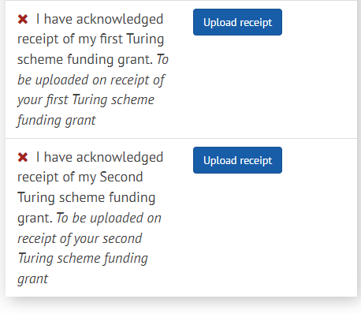
To upload the receipt, simply click the “Upload receipt” button on the relevant task.
This will take you to a simple upload function. You can click “Browse my computer” to locate the file to upload.
Next, select the file you want to upload. The system will show you the file name and size and open a box in which you should enter a name for the file, before clicking “Upload”.
The Tool will tell you when the upload has been successful, and the file should be available for you to view by clicking on the file title.
Once you are happy with the upload, click “Continue”.
Now you will be taken to another screen where you can view, or remove the file, by either clicking the pen symbol or the dustbin symbol. If you are happy, click “Exit” to go back to the main page in the Tool. If required, you can delete and then upload another file.
Once uploaded, and after you have clicked “Exit” you will be returned to the main screen and will see that the task is ticked green and is now complete.
“Before I leave” contains an important task which verifies that your placement has been successful and confirms dates – these are used to calculate the final allowable Turing scheme grant.
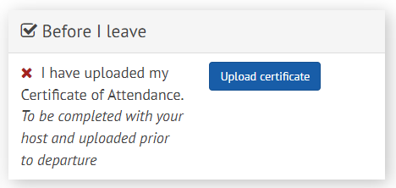
The task is to upload a Certificate of Attendance. We will email you with the document near the end of your placement. You need to ask your host institution to complete it with the start and end dates of your placement, and then you should upload it (as described above), by clicking “Upload certificate”.
The dates on this certificate will be used to make final calculations on your Turing scheme grant and may amend the amount on your original contract. We cannot pay the final instalment until we have received this document.
Some institutions will not provide this, in which case, please contact us directly at outbound@st-andrews.ac.uk to discuss the alternative.
The final section is “On my return”. This has two tasks to finalise your placement.
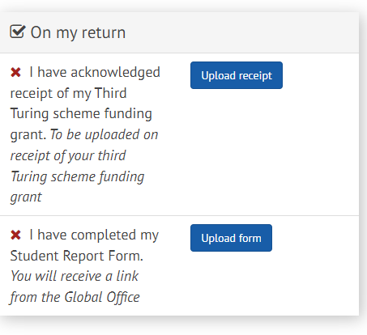
1. Your third Turing scheme grant receipt. This is acknowledgement that you have received your final 10% payment.
We will send you a copy of the form for completion. Please upload it here by clicking “Upload receipt”.
2. A Student Report Form.
This is a form that is used by the Global Office to help monitor placements abroad. We value your responses highly and rely on them to tell us about any issues, or any positives related to your placement. You will be sent a form by the Global Office at the end of your placement.
Once you have completed the form, save it to your computer and click “Upload form”, then follow the steps for uploading documents above.

Work Abroad placement – (non-Turing)

As mentioned above, the tasks you will see are dependent on your type of placement. For this type of placement, you will see a screen like this showing all of the tasks you should complete.
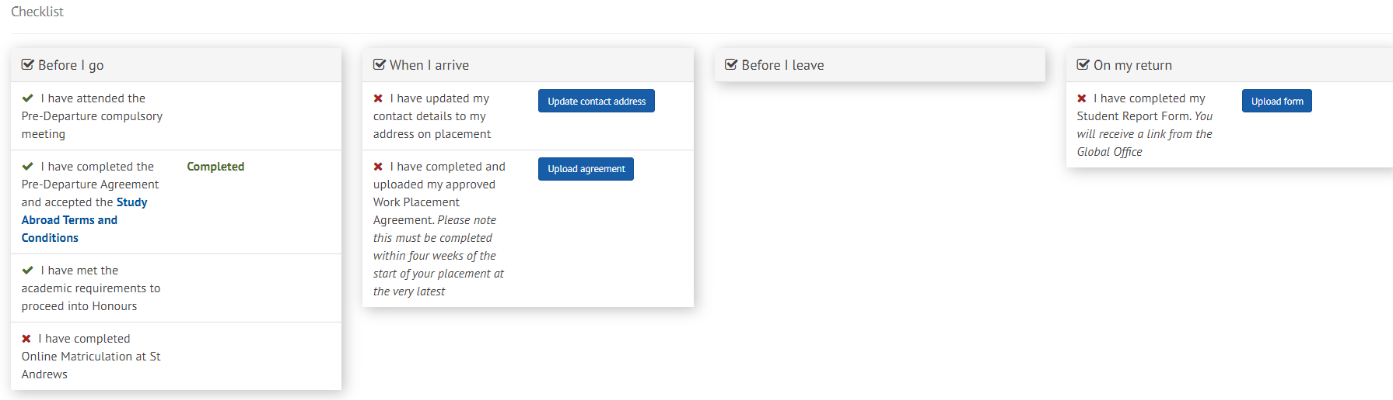

They are split into sections. Under the column “Before I go” you have the following four tasks:
1. Attend the Pre-Departure compulsory meeting.
This is an event run by the Global Office and you will be informed about it. We will take a record of your attendance and update the Tool for in the days after the meeting.
2. Complete the Pre-Departure Agreement and accept Study Abroad Terms and Conditions.
This is a two-stage task. Firstly, you should click on the blue link to the Study Abroad Terms and Conditions. This will take you to our website. Select the link for Programme terms and conditions, and then the ones related to your type of placement, then read them and make sure you understand them.
You will be asked to confirm you accept them as part of the Pre-Departure Agreement. Acceptance is a mandatory part of your eligibility for Study Abroad.
Next, click the button marked “Begin pre-departure task”.
The task asks you five questions. You must answer them all. To do so, simply select the drop-down box on each question and answer it. These responses will feed through to our administrative view of your Agreement. Completing the task will update that element and mark it with a green tick.
The next two elements in your “Before I go” section are validated when you complete a requirement outside of the tool.
3. The first is complete when you meet academic requirements to proceed to Honours which is a condition of your placement. This will be updated for you before your placement begins.
4. The second is complete when you finish Online Matriculation through the normal process each academic year. Both will be updated for you when they have been done.
The next section is “When I arrive”. There are two elements to complete here.
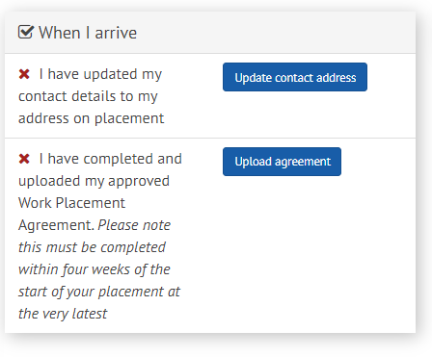
1. The first element is to ensure we have your correct contact details. This is extremely important so that we can contact you in case of need, so you must make sure they are always up to date. Once you reach your accommodation for your placement, you should click on the “Update contact address” link, update the information in the table below, and this will feed through to our other systems for you.
Although this will be marked complete once you have done this, you should remember to update your details through the normal task in MySaint any other time you move location within the same Study Abroad period.
2. The second element is an online task to allow you to upload a completed Work Placement Agreement.
You should complete this with your Work Abroad Co-ordinator, your host institution, and sign it yourself. It should also be signed by the Global Office.
Once complete, you should upload it here, using the “Upload agreement” button.
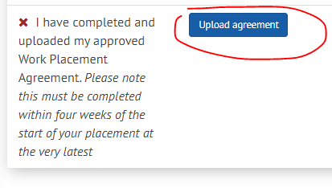
This will take you to a simple upload function. You can click “Browse my computer” to locate the file to upload.
Next, select the file you want to upload. The system will show you the file name and size and open a box in which you should enter a name for the file, before clicking “Upload”.
The Tool will tell you when the upload has been successful, and the file should be available for you to view by clicking on the file title.
Once you are happy with the upload, click “Continue”.
Now you will be taken to another screen where you can view, or remove the file, by either clicking the pen symbol or the dustbin symbol. If you are happy, click “Exit” to go back to the main page in the Tool. If required, you can delete and then upload another file.
Once uploaded, and after you have clicked “Exit” you will be returned to the main screen and will see that the task is ticked green and is now complete.

The next section is “Before I leave”. This section is not relevant if you are a study abroad student not funded by the Turing scheme. Nothing will show here, and you should not have anything to complete in this section.

“On my return” is the last section. There is one task here.
This is a form that is used by the Global Office to help monitor placements abroad. We value your responses highly and rely on them to tell us about any issues, or any positives related to your placement. You will be sent a form by the Global Office at the end of your placement.
Once you have completed the form, save it to your computer and click “Upload form”, then follow the steps for uploading documents above.

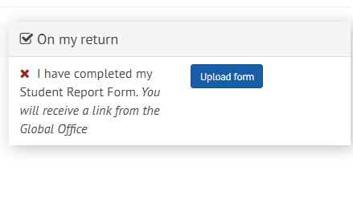

Work Abroad placement – (Turing)

As mentioned above, the tasks you will see are dependent on your type of placement. For this type of placement, you will see a screen like this showing all of the tasks you should complete.

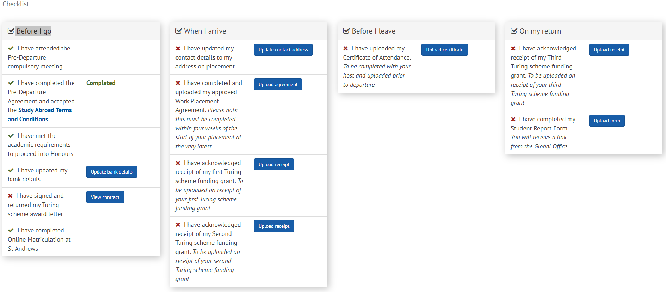
They are split into sections. Under the column “Before I go” you have the following tasks:
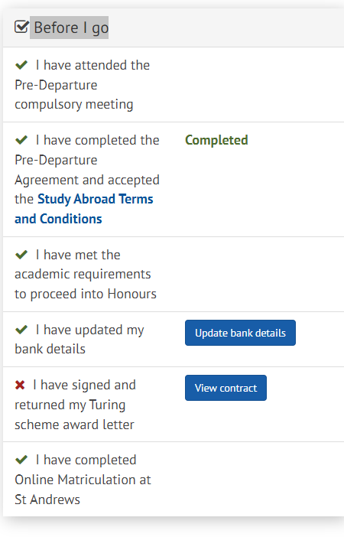
1. Attend the Pre-Departure compulsory meeting.
This is an event run by the Global Office and you will be informed about it. We will take a record of your attendance and update the Tool for in the days after the meeting.
2. Complete the Pre-Departure Agreement and accept Study Abroad Terms and Conditions.
This is a two-stage task. Firstly, you should click on the blue link to the Study Abroad Terms and Conditions. This will take you to our website. Select the link for Programme terms and conditions, and then the ones related to your type of placement, then read them and make sure you understand them.
You will be asked to confirm you accept them as part of the Pre-Departure Agreement. Acceptance is a mandatory part of your eligibility for Study Abroad.
Next, click the button marked “Begin pre-departure task”.
The task asks you five questions. You must answer them all. To do so, simply select the drop-down box on each question and answer it. These responses will feed through to our administrative view of your Agreement. Completing the task will update that element and mark it with a green tick.
The next element in your “Before I go” section is validated when you complete a requirement outside of the tool.
3. This is complete when you meet academic requirements to proceed to Honours which is a condition of your placement. This will be updated for you before your placement begins.
4. Next, you have the ability to access a tool to update your bank details. You should always check that you have the relevant bank details listed in MySaint.
This task feeds through to your details and allows you to add the account information so that we can make payments to you for your Turing scheme grant.
Once you have completed it, the task will show with a green tick next to that element.
5. Next you need to ensure that you have checked, signed, and returned your Turing award letter. This will be sent to you via email after your placement has been confirmed, in the summer. You should check it carefully, complete any missing elements, sign it, and return it to the Global Office at outbound@st-andrews.ac.uk
We will upload it for you, and you will be able to see it by clicking “View contract”.
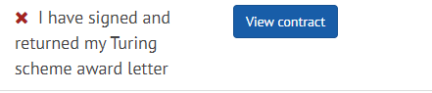
6. The sixth task is complete when you finish Online Matriculation through the normal process each academic year. Both will be updated for you when they have been done.

The next section is “When I arrive”. There are four elements to complete here.
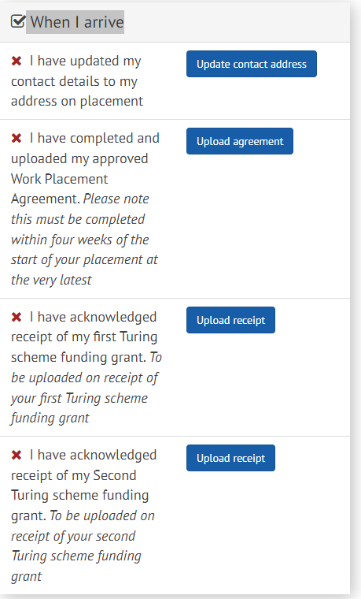
1. The first element is to ensure we have your correct contact details.
This is extremely important so that we can contact you in case of need, so you must make sure they are always up to date. Once you reach your accommodation for your placement, you should click on the “Update contact address” link, update the information in the table below, and this will feed through to our other systems for you.
Although this will be marked complete once you have done this, you should remember to update your details through the normal task in MySaint any other time you move location within the same Study Abroad period.
2. Task two is to upload a completed Work Placement Agreement.
This will be sent to you at the start of your placement, and should be completed by you, your Study Abroad Co-ordinator, the host institution, and finally should be signed by the Global Office.
Once complete, it can be uploaded by clicking on the button “Upload agreement”.
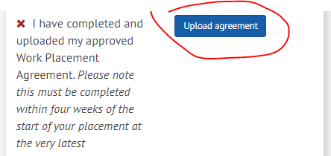
This will take you to a simple upload function. You can click “Browse my computer” to locate the file to upload.
Next, select the file you want to upload. The system will show you the file name and size and open a box in which you should enter a name for the file, before clicking “Upload”.
The Tool will tell you when the upload has been successful, and the file should be available for you to view by clicking on the file title.
Once you are happy with the upload, click “Continue”.
Now you will be taken to another screen where you can view, or remove the file, by either clicking the pen symbol or the dustbin symbol. If you are happy, click “Exit” to go back to the main page in the Tool. If required, you can delete and then upload another file.
Once uploaded, and after you have clicked “Exit” you will be returned to the main screen and will see that the task is ticked green and is now complete.
3, 4. Items 3 and 4 are both for upload of receipts for your Turing scheme payments.
Grants are paid in instalments. You will have received a message from us with your Turing scheme award letter which will explain how many payments you will receive. This depends on your placement duration. If you only receive two payments, you DO NOT need to use the Second grant receipt task. You will also see how much you will be paid at the outset of your placement in the same message. You will receive that amount before or near the start of your placement as long as you have completed the required tasks beforehand, including returning a fully signed contract to us. Second and third instalments are released during the placement, and once the previous instalments have been receipted unless your placement only has two payments.
Each time we make a payment, we will contact you with a copy of the receipt and a request to complete it. When you receive this, you should check that you have the funds in your account, then upload a receipt to the relevant task within the Tool.
The uploads work in the same way as described above.
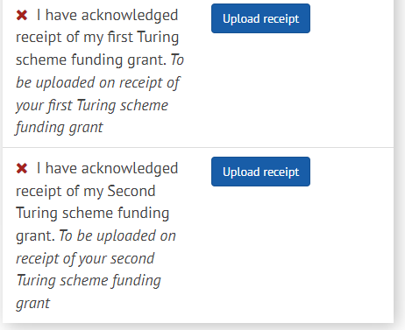
“Before I leave” contains two important tasks which verify that your placement has been successful and confirm dates.
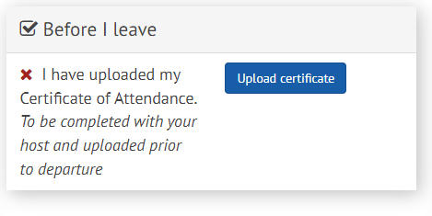
The task is to upload a Certificate of Attendance. We will email you with the document near the end of your placement. You need to ask your host institution to complete it with the start and end dates of your placement, and then you should upload it (as described above), by clicking “Upload certificate”.
The dates on this certificate will be used to make final calculations on your Turing scheme grant and may amend the amount on your original contract. We cannot pay the final instalment until we have received this document.
Some institutions will not provide this, in which case, please contact us directly at outbound@st-andrews.ac.uk to discuss the alternative.
The final section is “On my return”. This has three tasks to finalise your placement.
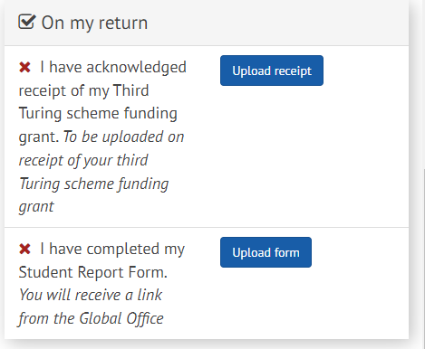
1. Your third Turing scheme receipt. This is acknowledgement that you have received your final 10% payment.
We will send you a copy of the form for completion. Please upload it here by clicking “Upload receipt”.
2. A Student Report Form.
This is a form that is used by the Global Office to help monitor placements abroad. We value your responses highly and rely on them to tell us about any issues, or any positives related to your placement. You will be sent a form by the Global Office at the end of your placement.
Once you have completed the form, save it to your computer and click “Upload form”, then follow the steps for uploading documents above.

Work placement - UK

As mentioned above, the tasks you will see are dependent on your type of placement. For this type of placement, you will see a screen like this showing all of the tasks you should complete.
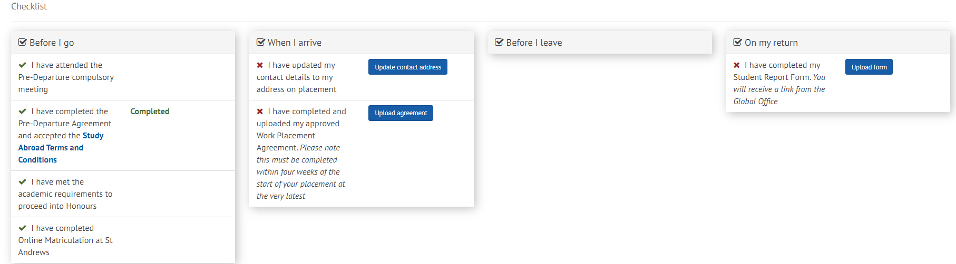

They are split into sections. Under the column “Before I go” you have the following four tasks:
1. Attend the Pre-Departure compulsory meeting.
This is an event run by the Global Office and you will be informed about it. We will take a record of your attendance and update the Tool for in the days after the meeting.
2. Complete the Pre-Departure Agreement and accept Study Abroad Terms and Conditions.
This is a two-stage task. Firstly, you should click on the blue link to the Study Abroad Terms and Conditions. This will take you to our website. Select the link for Programme terms and conditions, and then the ones related to your type of placement, then read them and make sure you understand them.
You will be asked to confirm you accept them as part of the Pre-Departure Agreement. Acceptance is a mandatory part of your eligibility for Study Abroad.
Next, click the button marked “Begin pre-departure task”.
The task asks you five questions. You must answer them all. To do so, simply select the drop-down box on each question and answer it. These responses will feed through to our administrative view of your Agreement. Completing the task will update that element and mark it with a green tick.

The next two elements in your “Before I go” section are validated when you complete a requirement outside of the tool.
3. The first is complete when you meet academic requirements to proceed to Honours which is a condition of your placement. This will be updated for you before your placement begins.
4. The second is complete when you finish Online Matriculation through the normal process each academic year. Both will be updated for you when they have been done.
The next section is “When I arrive”. There are two elements to complete here.
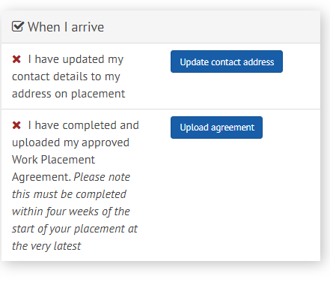
2. The second element is an online task to allow you to upload a completed Work Placement Agreement.
You should complete this with your Work Abroad Co-ordinator, your host institution, and sign it yourself. It should also be signed by the Global Office.
Once complete, you should upload it here, using the “Upload agreement” button.
This will take you to a simple upload function. You can click “Browse my computer” to locate the file to upload.
Next, select the file you want to upload. The system will show you the file name and size and open a box in which you should enter a name for the file, before clicking “Upload”.
The Tool will tell you when the upload has been successful, and the file should be available for you to view by clicking on the file title.
Once you are happy with the upload, click “Continue”.
Now you will be taken to another screen where you can view, or remove the file, by either clicking the pen symbol or the dustbin symbol. If you are happy, click “Exit” to go back to the main page in the Tool. If required, you can delete and then upload another file.
Once uploaded, and after you have clicked “Exit” you will be returned to the main screen and will see that the task is ticked green and is now complete.

The next section is “Before I leave”. This section is not relevant if you are a study abroad student not funded by the Turing scheme. Nothing will show here, and you should not have anything to complete in this section.

“On my return” is the last section. There is one task here.
This is a form that is used by the Global Office to help monitor placements abroad. We value your responses highly and rely on them to tell us about any issues, or any positives related to your placement. You will be sent a form by the Global Office at the end of your placement.
Once you have completed the form, save it to your computer and click “Upload form”, then follow the steps for uploading documents above.

